Mid-Term Task

Part I

1. Host a static website on Blob Storage: build and deploy a static Hello World website to Azure Storage
2. Verify that the default web page has the Hello World! page.
3. Provide the steps and results.

For this task first we go to the Azure Portal and create a storage

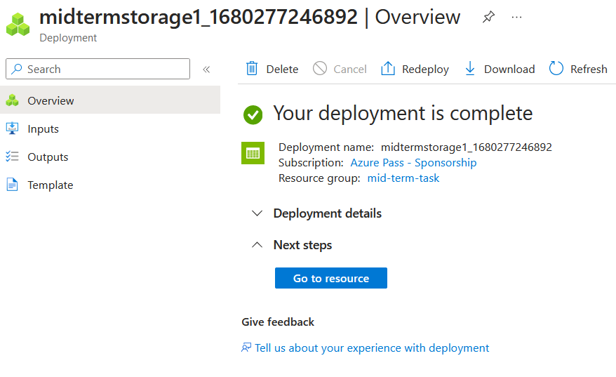

After this we go to the resource and from the Overview pane we select the Capabilities tab. Here we select Static website and enable it.

We specify a default index.html and 404.html page and save the configuration.

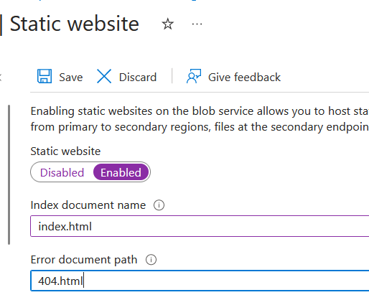

Now we open VS Code and go to extensions so we can install Azure Storage.

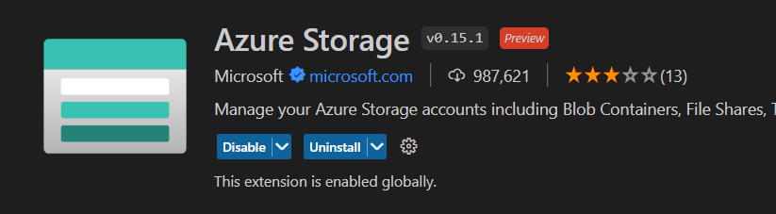

We sign in to Azure and then create a folder with two files index.html and 404.html.

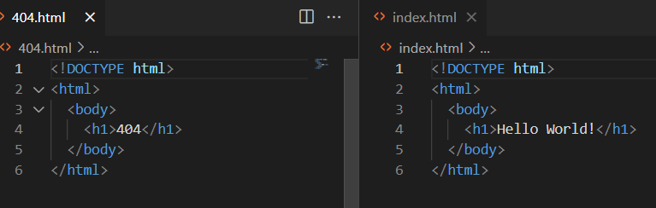

We can now deploy to our static website

And test that the Hello World page is showing in the browser.

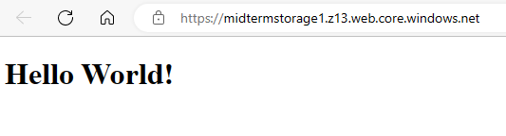

Part II

1. Create a Virtual Network where you will deploy your Linux Based Web Server.
2. Modify the network security group for your virtual machine that will allow you to remotely manage your machine only from your local machine and nowhere else.
3. Create a Linux Virtual Machine that will be your Web Server which is publicly available for web publishing (not SSL) only from your machine and nowhere else.

4. Connect to the VM.

5. Install Apache Web Server.

6. Deploy the “Hello World” web page.

7. Provide Testing from your cellphone.

8. Provide the steps and results.

First, we create a Virtual Network

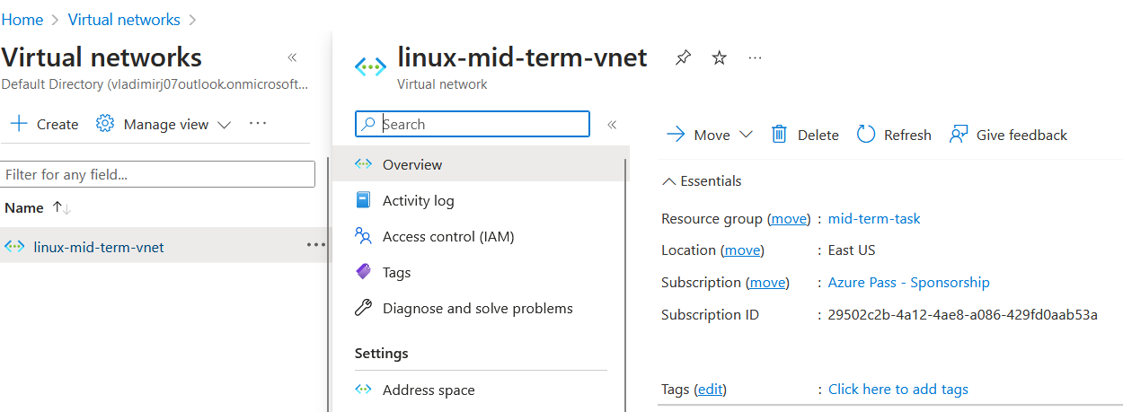

Then we add inbound rule to allow only My IP address and one to deny all with lower priority for SSH access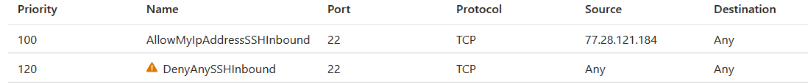

Now we can create a virtual machine and we can open port http - 80 and SSH - 22

I connected to the VM with PuTTY

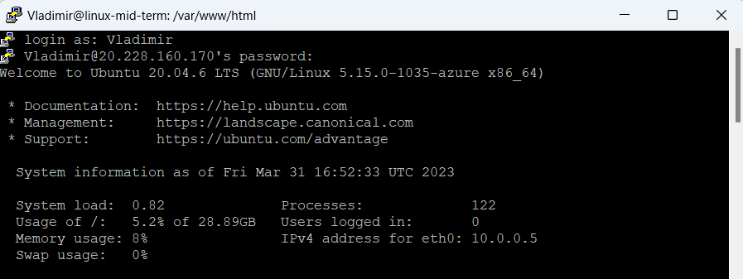

and installed Apache Web Server with the command “sudo apt install apache2”

With the help of nano I created index.html file

And tested it in the browser

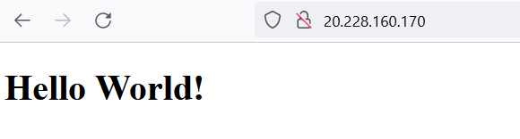

The hello world page is accessible from my phones browser.